STRATHMORE UNIVERSITY
MSc in Sustainable Energy Transition

A Household Energy and Cost Comparison Tool for Supporting the Clean Cooking Transition in Kenya

Capstone Project Final Report

Student No: 223757
July 2026

Abstract
Cost is the barrier households cite most often when considering a switch to electric cooking, yet the cost information available to them is generic: it assumes one fuel, one household, and a fixed menu. This project built a decision-support tool that computes the monthly cost, savings, and payback period of cooking fuel and appliance choices for a specific Kenyan household, using measured performance data from Controlled Cooking Tests (CCTs) conducted under the eCooking Capacity Building and Market Development Programme (eCAP) rather than generic efficiency assumptions. The raw CCT dataset of 45 tests across ten appliances and seven dishes was cleaned and re-derived from first principles, correcting energy conversion errors of up to 14 times and resolving contradictory time records. A Python calculation engine joins this performance table to an editable file of current Energy and Petroleum Regulatory Authority (EPRA) tariffs and fuel prices, models fuel stacking, and prices electricity with full tariff-band logic, including the repricing that occurs when added cooking load moves a household across a band threshold. A Streamlit interface exposes the engine to non-technical users, and untested dish-appliance combinations are refused rather than estimated. Validation reproduced 30 of 42 published per-dish costs within 10 percent, with all divergences traced to price inconsistencies in the source report; the induction cooker payback benchmark matched the published figure within one month. In a worked example, a four-serving household replacing a charcoal and LPG stack with an electric pressure cooker and induction cooker saves approximately KSh 931 per month and recovers the appliance investment in about 22 months, a result that is robust to a 20 percent rise in electricity prices.
Key words

1. Introduction and Background
Access to clean cooking remains one of the most persistent development challenges in sub-Saharan Africa. The International Energy Agency (2025) estimates that around one billion people in the region still lack access to clean cooking, with roughly four in five households relying on polluting fuels such as firewood, charcoal, and kerosene; the resulting household air pollution contributes to hundreds of thousands of premature deaths across Africa each year (World Health Organization, 2023). In Kenya, the Kenya National Cooking Transition Strategy identifies firewood as the primary cooking energy source for approximately 9.1 million households (Ministry of Energy and Petroleum, 2024a), and the national household cooking sector study found that 75 percent of households rely on wood fuel or charcoal, rising above 90 percent in rural areas (Ministry of Energy, 2019). These practices sit in direct tension with the national goal of universal access to clean cooking by 2028 and with Sustainable Development Goal 7 on affordable and clean energy (United Nations, 2015).
Electric cooking is a central pillar of the national response. The Kenya National eCooking Strategy targets scaled adoption of energy-efficient electric appliances (Ministry of Energy and Petroleum, 2024b), and empirical work has repeatedly shown that efficient appliances such as the electric pressure cooker (EPC) can cook staple dishes at lower running cost than charcoal, kerosene, or LPG (Banda et al., 2024; Perros et al., 2025). Adoption, however, is constrained by upfront cost and by attention: low-income households systematically under-invest in energy-efficient technologies even when the investment pays back quickly (Berkouwer & Dean, 2022). The main barrier is cost, or how costly people believe it to be, and because cooking cost depends heavily on which dish is cooked on which appliance for which household, general comparisons can mislead (Perros et al., 2025).

2. Problem Statement
Most cost comparisons available to Kenyan households are generic. They assume one fuel, one typical household, and a fixed set of meals, ignoring the factors that actually drive a household's cooking bill: household size, the dishes cooked and how often, the appliance used for each dish, and the electricity tariff band, which changes the unit price of power (Energy and Petroleum Regulatory Authority, 2023). They also ignore that most Kenyan households stack fuels, with over 80 percent owning at least two cookstoves (Ministry of Energy, 2019). As a result, families and the field agents advising them have no simple, evidence-based way to see the real cost, savings, and payback of switching to electric cooking.

Objectives
The main objective of this project was to build a tool that lets Kenyan households and clean cooking practitioners compare the energy use, monthly cost, savings, and payback period of different cooking fuels and appliances, grounded in Controlled Cooking Test measurements. The specific objectives were to:
- To implement a unit-tested calculation engine covering fuel stacking, tariff-band repricing, savings against the household's own baseline stack, and appliance payback;
- To provide a simple interface usable by clean cooking champions
- To validate the tool against independent studies, and test its sensitivity to price changes.

3. Data: The eCAP Controlled Cooking Test Dataset
The tool's performance engine is built on Controlled Cooking Tests conducted under the eCAP programme, a partnership between Kenya Power, Modern Energy Cooking Services (MECS), and UK PACT, at the Pika na Power kitchen in Nairobi (Banda et al., 2024). Following the MECS CCT protocol (Leary, 2023), eight cooks prepared seven common Kenyan dishes (beans, beef stew, rice, ugali, spinach, chapati, and chips) on ten appliances: six electric (EPC, induction cooker, rice cooker, air fryer, infrared cooker, and hot plate) and four non-electric (LPG, improved charcoal stove, kerosene, and ethanol). Each dish-appliance combination was tested at least twice, with a third test where the first two diverged by more than 15 percent, yielding 45 test records plus a single ugali test.

3.1 Data Preprocessing
The raw workbook could not be used directly. A dedicated cleaning script (clean_cct_data.py) was written to serve as both the transformation and the provenance record: every number used by the tool traces through it to a raw cell. Table 1 summarises the corrections applied.
Issue in raw data | Example | Treatment
Stored kWh-equivalents wrong for fuel appliances | Ethanol-rice stored as 6.117 kWh; correct value 0.43 kWh (14x error). Beef-charcoal stored as 13.28 kWh; correct 2.09 kWh | All kWh values for fuel appliances recomputed from raw fuel mass and calorific values; stored column discarded
Contradictory time columns | Kerosene-beans recorded as both 6,150 s and 12,300 s | All times recomputed from raw start/end timestamps and averaged over valid tests
Undocumented outlier | Ethanol-chips test 1 recorded 1,015 g vs 280 g and 220 g in tests 2-3 | Excluded under the study's own >15% divergence protocol; exclusion documented in code
Inconsistent appliance names | “Improved Improved Charcoal Stove”, “Airfyer” | Normalised to a controlled vocabulary
Suspect record | Chapati-LPG records 161 g of gas vs 20-30 g on all other fuels | Retained but flagged REVIEW; see Section 6.4
Table 1. Corrections applied in producing the validated lookup table (cct_lookup.csv).
The cleaned table holds, for each tested dish-appliance pair: fuel type, food weight, average fuel mass (non-electric), energy in kWh, cooking time in minutes, number of valid tests, cook ratings for ease of use and taste, and a notes field recording every correction. Figure 2 (Section 5) shows the resulting energy landscape.

4. Prices, Tariffs, and the Parameters
Prices change; physics does not. The tool therefore keeps the performance table free of any monetary value and stores all prices in an editable parameter file (parameters.csv) in which every entry carries its source, an as-of date, and a status flag distinguishing verified regulatory values, values that EPRA revises monthly, and retail prices that must be surveyed locally.
Electricity is priced using the current EPRA schedule. The base tariffs of the fourth tariff control period remain in force at KSh 12.23 per kWh for Domestic 1 (lifeline, average consumption up to 30 kWh per month), KSh 16.45 for Domestic 2 (31-100 kWh), and KSh 19.08 for Domestic 3 (Energy and Petroleum Regulatory Authority, 2023, 2026). On top of the base charge, the tool applies the monthly gazetted pass-through charges (fuel energy cost charge, foreign exchange adjustment, and water levy), the Rural Electrification Programme levy, the regulatory levy, and VAT, producing effective all-in costs of approximately KSh 19.3, 24.4, and 27.6 per kWh for the three bands at June 2026 charges. This is materially below the KSh 22.84-27.78 used in the 2023 eCAP analysis, which strengthens the economic case for electric cooking relative to that baseline.
Two features of the Kenyan tariff structure are modelled explicitly. First, a household's band is assigned from its average total consumption, and the entire bill is priced at that band; bands are not progressive tiers. Second, and consequently, adding electric cooking load can move a lifeline household above the 30 kWh threshold and reprice all of its electricity. The tool therefore computes the cost of electric cooking as the difference between the household's bill with and without the cooking load, rather than multiplying cooking kWh by a fixed rate. Generic comparisons do not capture this effect.

5. System Design and Implementation
The tool is implemented in Python as a small set of single-responsibility modules, shown in Figure 1. All computation lives in the engine; the interface is a thin layer that cannot introduce numbers of its own.
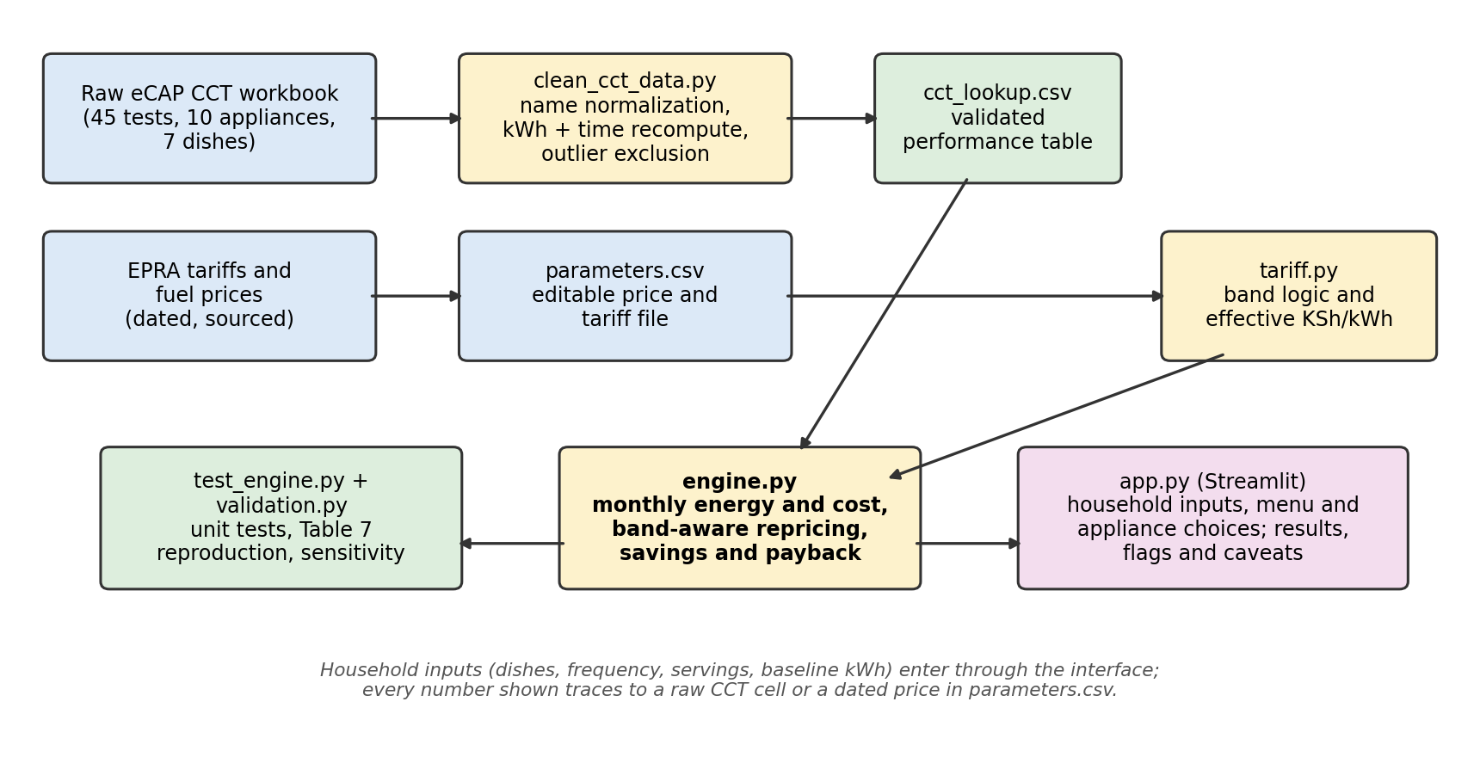
Figure 1. System architecture and data flow. Yellow modules compute, blue are data, green are validated outputs and tests, pink is the user interface.
The engine takes a menu, defined as a list of (dish, appliance, times per week) entries, so fuel stacking is the native representation rather than an afterthought: a household that boils beans on charcoal but fries on LPG simply lists different appliances per dish. Three design commitments from the concept note are enforced in code rather than in documentation:
- Untested combinations are refused. If a dish-appliance pair has no CCT record, the engine reports it as unavailable and excludes it from totals; the interface does not offer it at all. Coverage gaps are managed by design, not interpolated.
- Portion scaling is linear and stated. CCT results are for a two-portion test batch; household demand is scaled by servings divided by two. Because thermal losses do not scale with pot size, this overstates energy for large households, making results conservative upper bounds. The assumption is documented in the module and in the interface.
- Tariff-band repricing is always applied, as described in Section 4.
Correctness is protected by a unit-test suite (eight tests) covering band thresholds and ordering, the band-crossing repricing case, fuel cost arithmetic, scaling linearity, refusal of untested combinations, the no-savings payback edge case, and propagation of data-quality flags from the cleaning stage to results. Figure 2 shows the cleaned performance data the engine draws on.
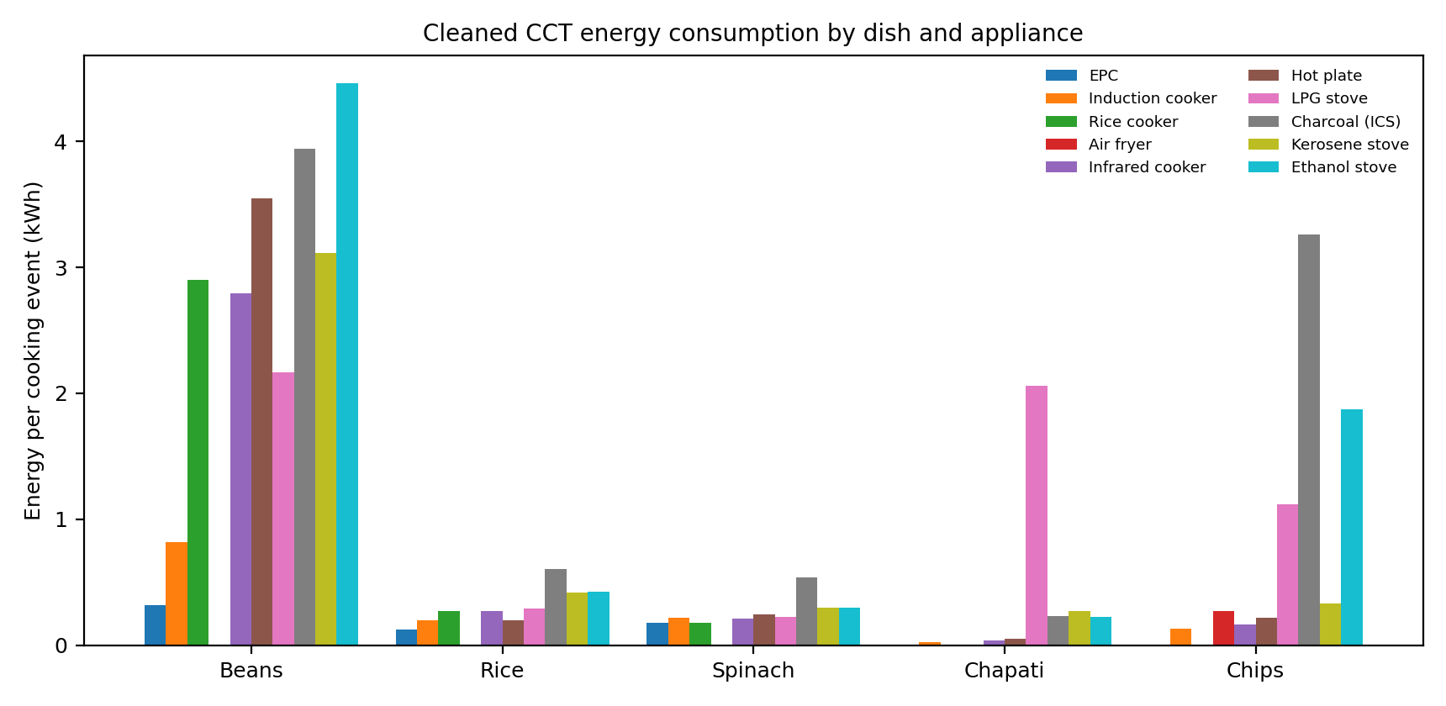
Figure 2. Cleaned CCT energy consumption per cooking event by dish and appliance. Gaps are untested combinations, which the tool never estimates.
The interface is a single-page Streamlit application. The user enters servings per meal and current non-cooking electricity use, sets a weekly frequency for each dish, and selects the current and proposed appliance per dish from dropdowns limited to tested combinations. Results show current and proposed monthly cost, savings, payback on appliances the user marks for purchase, the resulting tariff band with an explanation when a band change occurs, a cooking-time comparison, a per-dish breakdown, and any data caveats inherited from the cleaning stage.

6. Validation and Results

6.1 Reproduction of published per-dish costs
Fed the October 2023 prices used in the source study, the engine reproduces 30 of the 42 per-dish costs published in the eCAP report's summary table within 10 percent. Reverse-engineering the remaining twelve divergences showed that all of them originate in the source report rather than in the engine: the published table costed LPG at approximately KSh 172 per kg and kerosene at approximately KSh 169 per kg although its own assumptions state KSh 230 and KSh 203.06, and its electricity costs used the base lifeline charge only (KSh 12.23 per kWh), excluding pass-through charges and VAT and thereby understating true household electricity cost by roughly 40 percent. The engine is arithmetically consistent with the raw data throughout.

6.2 Payback benchmark
Recomputed under the source study's own assumptions (a baseline of LPG, charcoal, and kerosene in equal parts and a weekly menu of five of each dish type), the engine gives an induction cooker payback of 7 months against the published figure of approximately 8, and an EPC payback of 16 months against approximately 11; the EPC gap closes to about 14 months when the report's base-only electricity tariff is used. The tool's user-defined baseline is considered a methodological improvement over the equal-parts assumption, since households can be compared against what they actually cook with.

6.3 Worked example and sensitivity
Figure 3 shows the standard worked example: a four-serving household with 45 kWh per month of non-cooking electricity, currently boiling beans on an improved charcoal stove and cooking everything else on LPG, considering an EPC for the boiled dishes and an induction cooker for chapati and chips. Monthly cooking cost falls from about KSh 1,325 to KSh 394, saving KSh 931 per month; the combined appliance investment of KSh 19,995 is recovered in approximately 21.5 months; and cooking time falls from about 35 to 17 hours per month. The added 16 kWh per month places the household on the ordinary tariff band, an effect included in the figures.
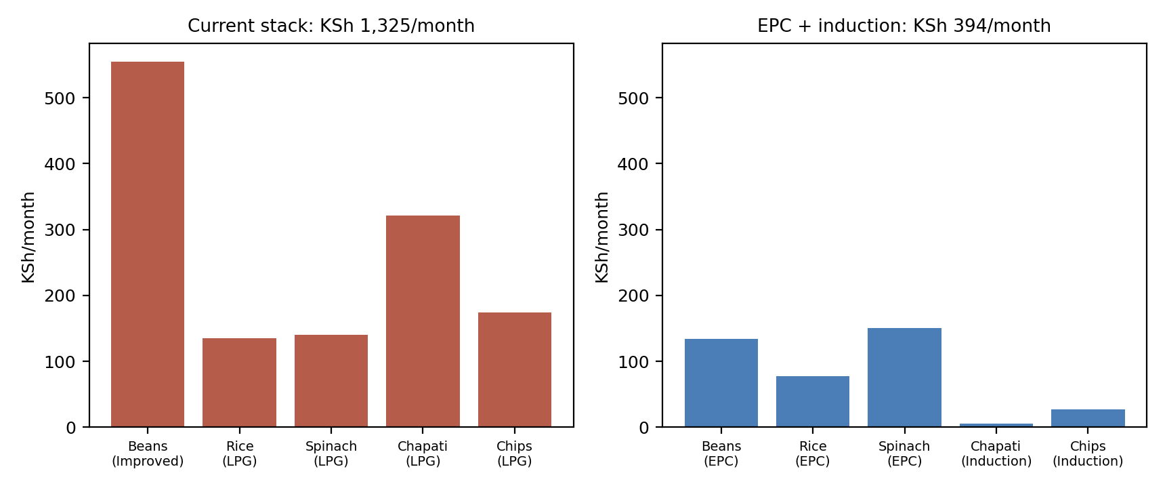
Figure 3. Worked example: per-dish monthly cooking cost, current stack versus proposed EPC and induction combination.
Figure 4 shows the sensitivity of the worked-example payback to a 20 percent change in key prices. Savings are most sensitive to the LPG price, with payback ranging from 18.4 to 25.7 months. Notably, a 20 percent increase in electricity prices stretches payback only from 21.5 to 23.4 months: the case for efficient electric cooking is robust to plausible tariff increases, because the efficient appliances use so little energy that the fuel they displace dominates the economics.
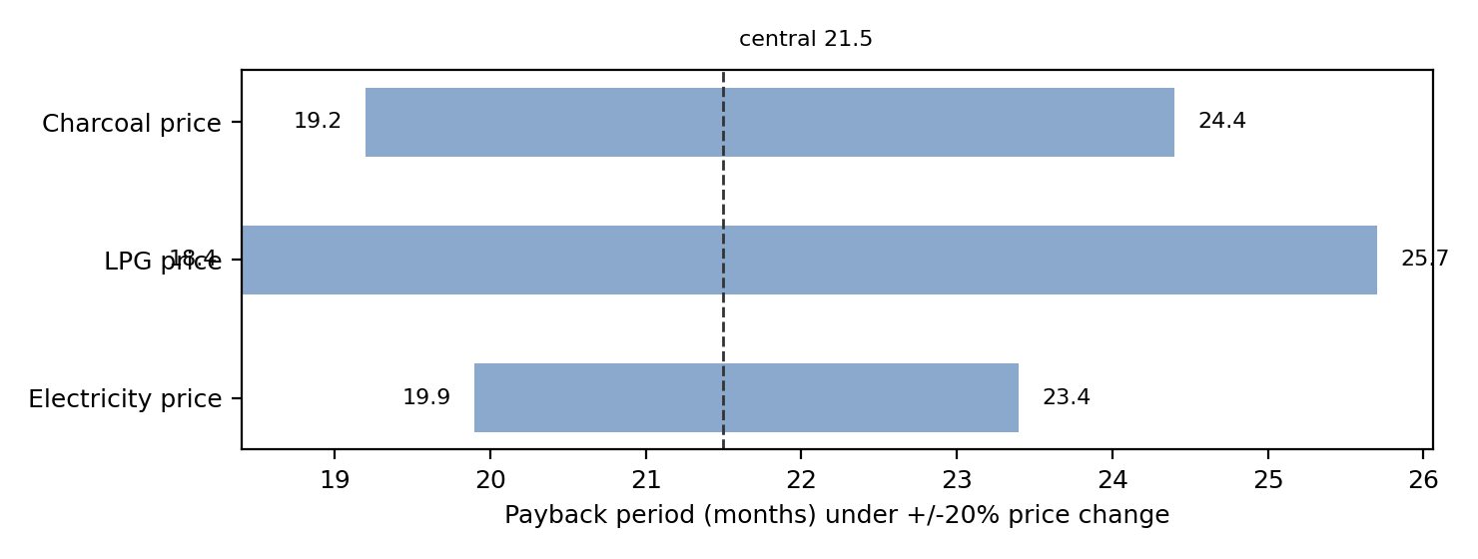
Figure 4. Payback period of the worked example under a 20 percent change in each price, holding the others constant.

6.4 A data finding: the chapati-LPG record
Validation resolved the one record flagged REVIEW during cleaning. The raw workbook records 161 g of LPG for chapati, against 20-30 g on every other fuel. The source report's cost table prices chapati on LPG at KSh 3.4, which implies roughly 20 g of gas, while its energy table used the raw 161 g; the two are irreconcilable. The raw record is therefore concluded to be a transcription error with a true value of approximately 15-20 g. Pending confirmation against the original field sheets, the value is retained but flagged, and users see the caveat whenever it affects their comparison; in the worked example it overstates LPG-baseline savings by roughly KSh 140 per month.

7. Discussion and Limitations
Three limitations bound the results. First, portion scaling is linear from a two-portion test batch; energy per serving falls as pot size grows, so estimates for large households are conservative upper bounds. Second, several CCT combinations rest on only two repetitions, and the source study itself notes that the short chapati tests are sensitive to small variations; the divergence flags in the lookup table propagate this uncertainty to users. Third, retail fuel prices vary widely by locality and dealer (Nairobi 13 kg LPG refills ranged from KSh 2,700 to KSh 3,510 in mid-2026), which is why prices live in an editable, dated parameter file rather than in code, and why the tool is most accurate when a field agent enters the prices a household actually pays.
The concept note framed the tool as serving both households and practitioners. As delivered, it is a practitioner's instrument: a Python application with an editable parameter file suits clean cooking champions, trainers, and researchers. A household-facing version (mobile or web deployment with maintained central prices) is feasible future work on the same engine.

8. Conclusion and Recommendations
The project delivered what the concept note promised: a working, validated, unit-tested comparison tool whose every output traces to a measured CCT value or a dated, sourced price. Its distinguishing features against generic comparisons are the household-specific menu and stacking model, the band-aware electricity pricing including threshold-crossing repricing, the refusal to estimate untested combinations, and the transparent propagation of data-quality flags to end users.
Three recommendations follow. First, confirm the chapati-LPG record against the original field sheets and correct it at the source, then rerun the pipeline. Second, extend the CCT dataset where the value per test is highest: EPC tests for chapati and chips would complete the coverage of the most efficient appliance, and additional repetitions would tighten the combinations currently flagged for divergence. Third, deploy the tool with eCooking champions under the Kenya National eCooking Strategy and collect structured feedback on whether shilling-denominated, household-specific payback figures shift purchase decisions, which is ultimately the behavioural question the tool exists to answer (Berkouwer & Dean, 2022; Ministry of Energy and Petroleum, 2024b).

References
Banda, S., Oribo, N., Maua, J., Wambugu, A., Leary, J., Spencer, J., & Wanjohi, I. (2024). Cooking appliance comparison for common foods in Kenya (January 2024 working paper). eCooking Capacity Building & Market Development Programme (eCAP), Kenya Power / Modern Energy Cooking Services / UK PACT. https://mecs.org.uk/
Batchelor, S. (2023). Energy transfer in kitchen appliances. Modern Energy Cooking Services. https://mecs.org.uk/blog/energy-transfer-in-kitchen-appliances/
Berkouwer, S. B., & Dean, J. T. (2022). Credit, attention, and externalities in the adoption of energy-efficient technologies by low-income households. American Economic Review, 112(10), 3291–3330. https://doi.org/10.1257/aer.20210766
Energy and Petroleum Regulatory Authority. (2023). Retail electricity tariff review for the 2022/23–2025/26 fourth tariff control period. EPRA. https://www.epra.go.ke/retail-electricity-tariff-review-for-the-2022-23-2025-26-4th-tariff-control-period-tcp-effective-1st-april-2023/
Energy and Petroleum Regulatory Authority. (2026). Electricity tariff regulatory instruments and monthly schedule of tariff adjustments. EPRA. https://www.epra.go.ke/electricity-tariff-overview
International Energy Agency. (2025). Universal access to clean cooking in Africa: Progress update and roadmap to implementation. IEA. https://www.iea.org/reports/universal-access-to-clean-cooking-in-africa
Leary, J. (2023). MECS controlled cooking test (CCT) protocol. Modern Energy Cooking Services. https://mecs.org.uk/
Ministry of Energy. (2019). Kenya household cooking sector study. Government of Kenya.
Ministry of Energy and Petroleum. (2024a). Kenya national cooking transition strategy (KNCTS) 2024–2028. Government of Kenya.
Ministry of Energy and Petroleum. (2024b). Kenya national eCooking strategy (KNeCS) 2024–2028. Government of Kenya.
Osiolo, H. H., Marwah, H., & Leach, M. (2023). The emergence of large-scale bioethanol utilities: Accelerating energy transitions for cooking. Energies, 16(17), 6242. https://doi.org/10.3390/en16176242
Perros, T., O’Keefe, M., Mwitari, J., Gichane, L., Puzzolo, E., & Pope, D. (2025). Comparing the financial, energy and time costs of different food and stove combinations in Nairobi using controlled cooking tests and longitudinal fuel price data. UCL Open: Environment. https://doi.org/10.14324/111.444/ucloe.3034
United Nations. (2015). Transforming our world: The 2030 agenda for sustainable development. United Nations. https://sdgs.un.org/2030agenda
World Health Organization. (2023). Household air pollution and health. WHO. https://www.who.int/news-room/fact-sheets/detail/household-air-pollution-and-health

